The product owner is commonly a lead user of the system or someone from marketing, product management or anyone with a solid understanding of users, the market place, the competition and of future trends for the domain or type of system being developed. This, of course, varies term based on whether the team is developing commercial software, software for internal use, hardware or some other type of product. The key is that the person in the product owner role needs to have a vision for what is to be built.

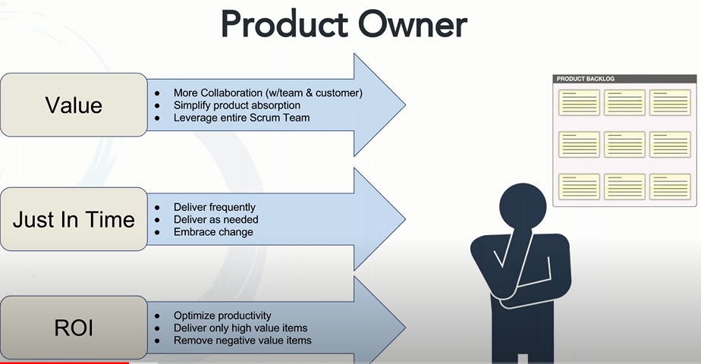

Product Owner Responsibilities:
- Ensures user stories are “ready” for development to start work.
- Ensures each story has the correct acceptance criteria.
- Gathers, manages, and prioritizes the product backlog.
- Ensures close collaboration with the development team.

Product Owner Responsibilities: Key Deliverables
- Product vision
- Problem statements and scenarios
- Product roadmaps
- Epics and User Stories
- Supporting documents, images, and, possibly, rough wire frames for user stories.
Product backlog
Product owner is responsible for the product backlog. They work with project managers and business analysts. PBI define the product value delivered by the system.

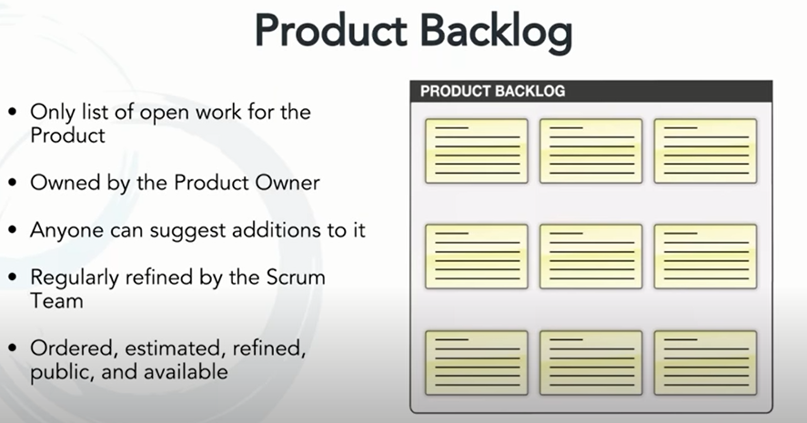

Examples of Product Backlog Item

Requests for new features originate from a multitude of sources. These include end users, sales, support, product management, and so on. New features can be the most difficult to prioritize as you 1. New Features
try to balance the competing needs of:
- Keeping existing customers satisfied.
- Meeting near-term sales opportunities.
- Working toward a longer-term vision of your product.
The product owner should monitor these sources routinely and resolve any conflicting requests. Doing so will help make sure the backlog contains new features that both attract new customers and build loyalty with existing ones.
As a <new feature>, I want <to be understood and prioritized appropriately> so that <I can deliver maximum value to customers and owners>.

2. Technical department
Technical debt includes work that needs to be done for the product to stay up to date and be maintainable. Examples of PBIs to address technical debt include upgrading to the latest third-party libraries, making architectural changes to support better scalability, or refactoring the source code to prevent future maintenance issues. When technical debt builds up whether deliberately or unknowingly you can risk delaying product releases.
Technical debt is often the result of change regarding:
- Direction and scope.
- Performance and scalability expectations.
- Technology or best practices.
These types of PBIs are often referred to as” technical debt” because of their similarity to financial debt; you will have to pay interest for them, but in the form of a longer development lifecycle. These tasks should be added to the backlog, and then prioritized along with features and defects, so they can be included in the planning cycle.
As <technical debt>, I want < to be understood and prioritized appropriately> so that <we can maintain and improve the product without delay>.
3. Bugs
Bugs and defects are problems discovered by end users that escaped quality control during development. In a Waterfall process, testing is often the last step of the development lifecycle. It’s quite common to push a release live with a large collection of minor (and sometimes moderate) defects. Bugs tend to cluster and accumulate over time if they aren’t resolved. They are sometimes managed within an issue tracker, but can also be included as a part of the backlog.
As a <bug>, I want <to be understood and prioritized appropriately> so that <problems are addressed early and the product is high quality>.
4. Research
is another item the end user won’t recognize as a feature, but can be included in a backlog. Research is instrumental when you know very little about how to implement a new feature or concept, or want to try something new. Either way, circumstances require you set aside time to expand the team’s understanding. The output of these user stories, commonly called “spikes”, is not working code, but in Research knowledge.
As <research>, I want <to be understood and prioritized appropriately> so that <we can lower business risk and innovate>

